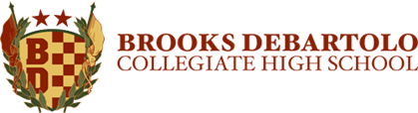
Brooks DeBartolo AP Scholar Notification of Achievement
The AP Scholar Awards recognize high school students who have demonstrated exemplary college-level achievement on AP Exams. BDCHS recognizes the Scholars at the senior celebration and at graduation by wearing their respective cords.
AP Scholar Criteria:
- Earned a 3 or higher on 3 or more AP Exams
- Maintained a “B” average or higher in all AP Courses Sem I senior year
AP Scholar Swag:
- Senior Celebration Recognition
- AP Scholar Graduation Cord
- Name added to AP Scholar bulletin board
- PIZZA PARTY!!
If you have earned the AP Scholar designation please follow the directions below and submit this form to Mrs. Shattuck (208) no later than Friday, February 14th.
Student Name: ________________________________________
Homeroom: ____________________________
 | AP Scholar | Granted to students who receive scores of 3 or higher on three or more AP Exams
 | AP Scholar with Honors | Granted to students who receive an average score of at least 3.25 on all AP Exams taken, and scores of 3 or higher on four or more of these exams
 | AP Scholar with Distinction | Granted to students who receive an average score of at least 3.5 on all AP Exams taken, and scores of 3 or higher on five or more of these exams
 | National AP Scholar | Granted to students in the United States who receive an average score of at least 4 on all AP Exams taken, and scores of 4 or higher on eight or more of these exams
According to College Board, please check the highest level of AP Scholar Distinction have you earned:

Current AP Courses and Grades:
Course: | Q1 | Q2 | Midterm
(1)
(2)
(3)

Please print and attach the following:
- Semester I Report Card
- College Board Transcript

Student Signature: _____________________________________ Date: _______________

